Quilts: More than blankets
Thomas Knauer learned all he needed to know about quilting from his daughter, he explained this at his lecture Thursday in Susman Theater at Drake University.
At his lecture The Meaning of Things: The Importance of Quilts in an Era of Excess, Knauer explained what he sees as the implications of quilts.
He did not start out quilting. He said quilting was an accident.
Knauer started out as a professor of Art, he was then struck with a rare form of muscular dystrophy and unable to do much as he was bed ridden for some time.
He wanted to be involved in his daughter’s life though, part of this was helping her pick out clothes with the aid of a laptop.
He did not like the gendered clothing for toddlers. All he wanted for his daughter was a gender-neutral dress, Knauer said. A dress that did not have a saying like ‘Bieber’s next girlfriend’.
He had his mother get the sewing machine down from the attic and began. The resulting dress is pictured.
Knauer said his daughter was so excited over a simple dress that he began to experiment.
As mentioned on his website, ThomasKnauerNews.com, “From there it was a logical leap to jump into textile design. I am a math geek with MFAs in Sculpture and Printmaking; I had spent the previous seven years as a design professor. I love sewing wee dresses, but patterns were calling me.”
His daughter’s reaction, her amazement to his first quilt, led him down the rabbit hole on quilting, Knauer said. He wanted to discover the implications behind quilts.
He began the lecture by defining what he considered the key points of the title of the lecture – thing, excess, and quilt.
Things, things speak in a way words can’t. They give an experience of an idea, Knauer said.
He said. “they are the same object but not the same thing.”
Excess, was the simple fact that we have more stuff and we have more access to stuff than before, Knauer said.
He said, “it’s not like the things have become less important, it’s just a different relationship”
Quilts began as practical things, he said. Something to not let us freeze. But they have since 1976, during the American quilt revival, and have since become attachments.
Quilts are these things vibrating with life, Knauer said.
The American Quilt revival, he said, was a “moment of looking back. Now everyone thinks of quilt as being passed down with stories of grandparents, and great-grandparents. We have these metaphors of quilts being about safety, love and affection.”
Having explain his title, Knauer utilized humor and stories of his own life, to detail what he saw as the implications of quilts.
One day he and his daughter were holding hands and walking down the street. She told him, “we make an H.”
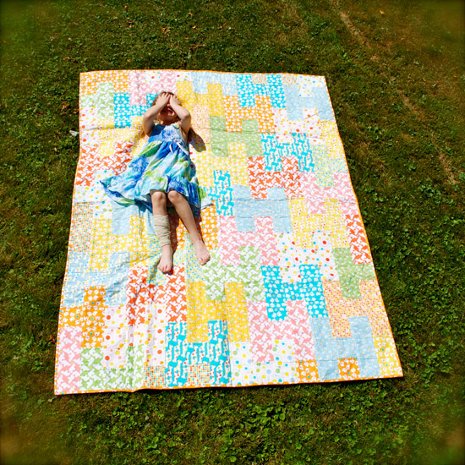
Knauer said this was inspiring. He went home later that day and made a quilt.
When she saw it, she told him “that quilt is us.”
That Knauer said taught him all he’d need to know about quilts.
“Quilts are translations of things,” he said.
Picture from lecture. Pictured is Knauer’s daughter

He said he was translating life into form. Asking himself what is his world? What are the things he wants to hold onto and make permanent?
That is where his quilts come from, Knauer said.
Some in attendance like Erin Opar found the lecture interesting.
Opar, a sophomore English-painting double major, said the lecture was interesting, that it showed the importance of putting yourself into your work
An estimated a total of 55 people were in attendance. The audience seemed to be a mix of alums, professors, students and people from the community.
No one left until the question and answer part of the lecture.
Professor Lenore Metrick-Chan, a professor of art history, said that the lecture allowed for people to see work that was not accessible at first glance. That a second glance reveals more.
Currently, there is an exhibit of Knauer’s work at the Anderson Art Gallery, located in the Fine Arts building. It is titled, Beyond Patterns: Activism and Identity in Quilts. It will be shown until Friday, Sept. 30.

